**Include image analysis features in an image processing request**

**Explore pricing options**

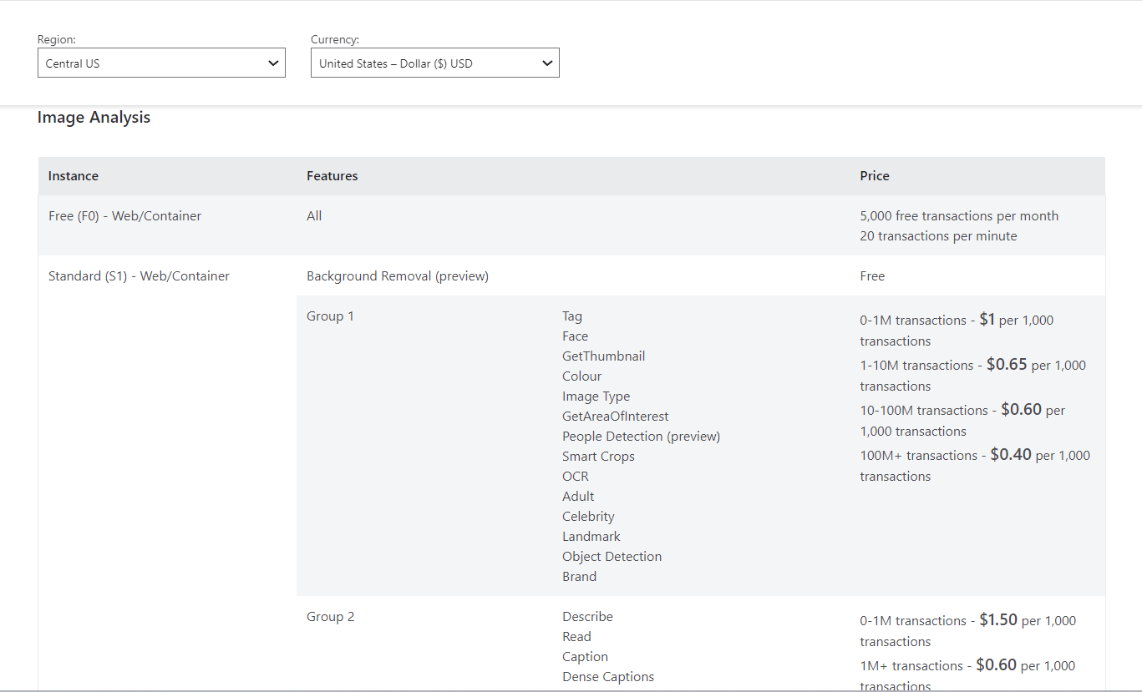

Each feature you select is counted as a transaction. There are a few special cases to note:

1. Analyse allows you to select multiple features at once. For instance, an Analyse call specifying the Tag, Face and Adult features would count as three transactions.
2. Read allows you to upload multipage PDF documents. Each page is counted as a feature. For instance, a 200 page document would count as 200 transactions.
3. All GET calls to see the results of the async Read and Recognise Text features are counted as transactions but are free of charge.

Each operation that you call (either individually or through “Analyze”) will be counted as a transaction. The total bill will be based on the number of transactions for each type of operation within a monthly billing period.

As a specific example, let us say you make the following calls in a certain monthly billing period:

* 1,500,000 **Analyse** operations, each calling both **Tag** and **Describe** operations
* 500,000 **OCR** operations
* 4,000,000 **Recognise Text** operations

Your total bill will be constructed as follows:

